Week 5 Visualization

Larissa

2022-06-26

## Top 15 Number of High Risk per Hospital

Below chart shows the Metropolitan or Micropolitan Area in the United States with the top 15 numbers of high risk of covid-19 per hospital. The color of the bar chart indicates the state of the area. We can see that multiple areas in Florida show up in the top 15 of high risk per hospital.

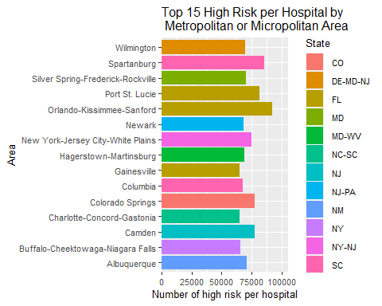

## The Number of Hospital

Despite the number of high risk, some areas only have few number of hospitals.

